ASSIGNMENT - DIGITAL MARKETING

|  |  |
| --- | --- |
| Reg No | 962820106010 |
| NAME | ASHINI P |
| NM ID | 04C4FD5FE2EEC2487604442F0937DBD0 |
| Date | 20-10-2023 |

1.Create a blog or website using Blogspot and WordPress. Customize the theme design and post new article with 500 words.

Link: https://gooraganics.blogspot.com/2023/09/organic-with-us_8.html

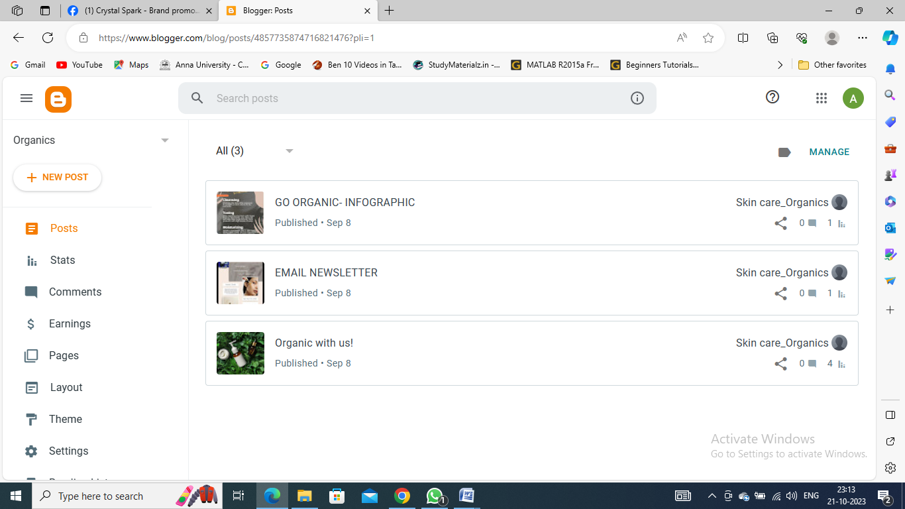

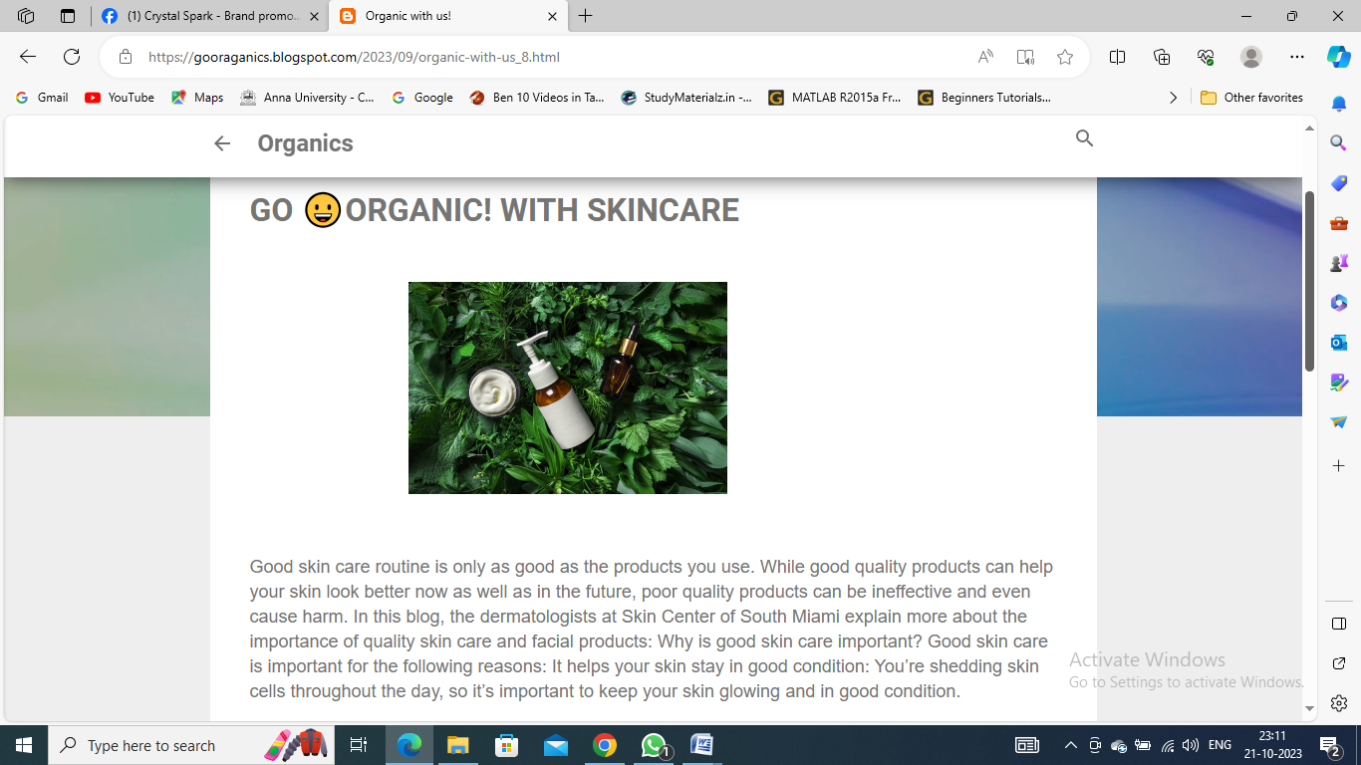

**2**.Create a new facebook page and post one social media poster for your brand.

Link: [https://www.facebook.com/butterflybrandclothing 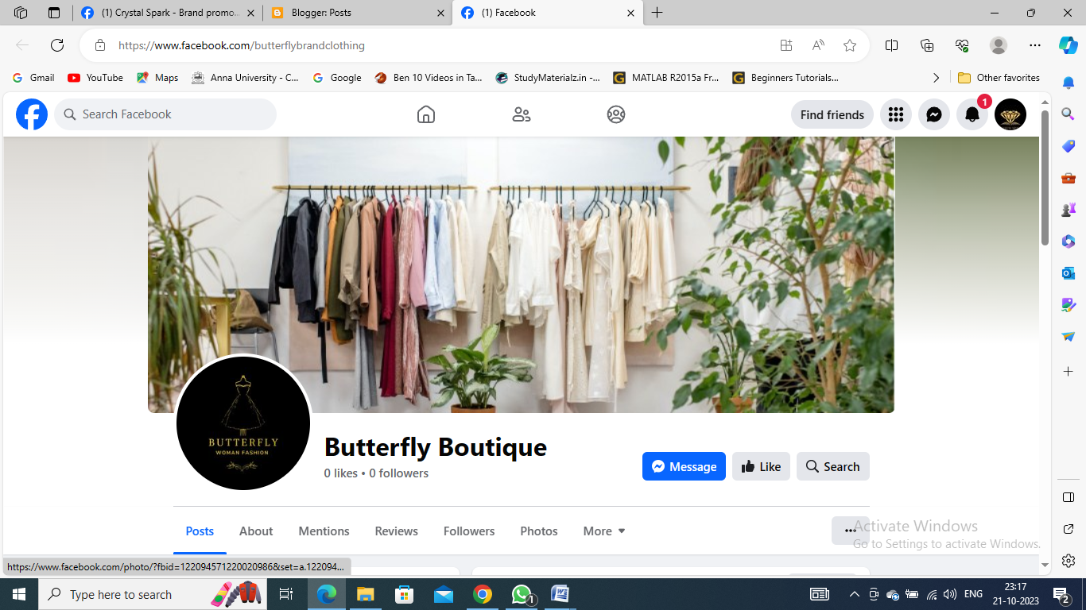](https://www.facebook.com/butterflybrandclothing%20#)

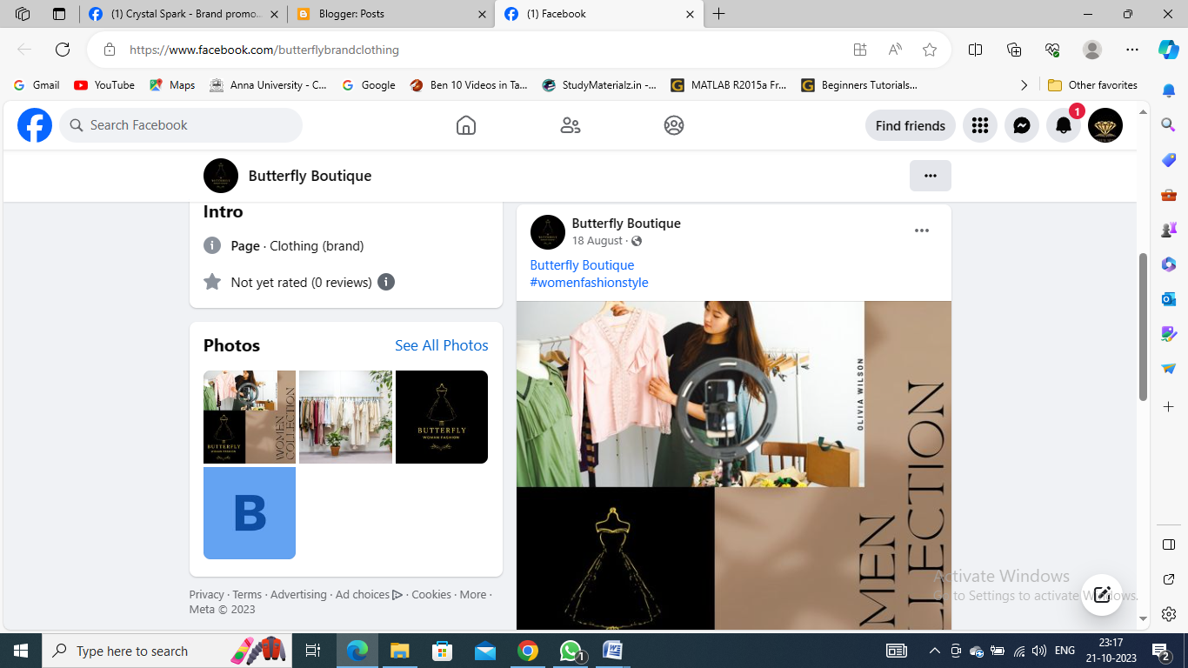

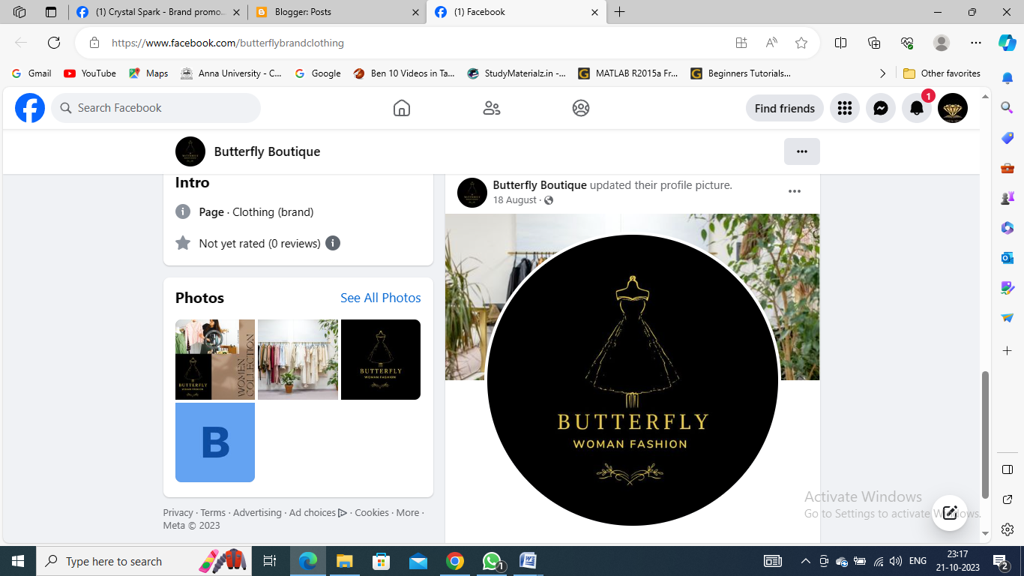

**3**.Create and design a social media advertisement poster using canva

Link: https://www.canva.com/design/DAFx6PHlBeM/FsAd0A8Wl-2fo8bqeBLrgw/edit?utm_content=DAFx6PHlBeM&utm_campaign=designshare&utm_medium=link2&utm_source=sharebutton



4.Create email newsletter design using MailChimp or canva tool.

Link:Using canva

<https://gooraganics.blogspot.com/2023/09/email-newsletter.html>



